CO2-ASSESSMENT TOOL-2
Name: TALARI VISHNUVARDHAN
Reg.no: 192572091
Course name: DESIGN AND ANALYSIS OF ALGORITHMS
Code: CSA0613
Faculty: Dr. F. MARY HARIN FERNANDEZ
Date: 29-07-2026
Question
Q39. A financial system maintains sorted transaction data for quick lookup using Binary Search, but frequent updates disrupt the order.
a) Explain how Binary Search operates on sorted data.
b) Analyze its performance when order is maintained versus disturbed.
c) Discuss the importance of maintaining sorted data.
Answer
(a) Explain how Binary Search operates on sorted data
Binary Search is a searching algorithm that works only on sorted data. It follows the Divide and Conquer technique by repeatedly dividing the search space into two halves.
Working Steps
- Find the middle element of the sorted transaction data.
- Compare the target transaction with the middle element.
- If both are equal, the transaction is found.
- If the target is smaller than the middle element, search the left half.
- If the target is greater than the middle element, search the right half.
- Repeat the process until the transaction is found or the search space becomes empty.
Example
Sorted Transaction Data:
[101, 205, 309, 412, 518, 624, 730]
Searching for 518
- Middle = 412
- 518 > 412 → Search right half
- Middle = 624
- 518 < 624 → Search left half
- Transaction 518 is found.
Time Complexity
- Best Case: O(1)
- Average Case: O(log n)
- Worst Case: O(log n)
Source Code Screenshot
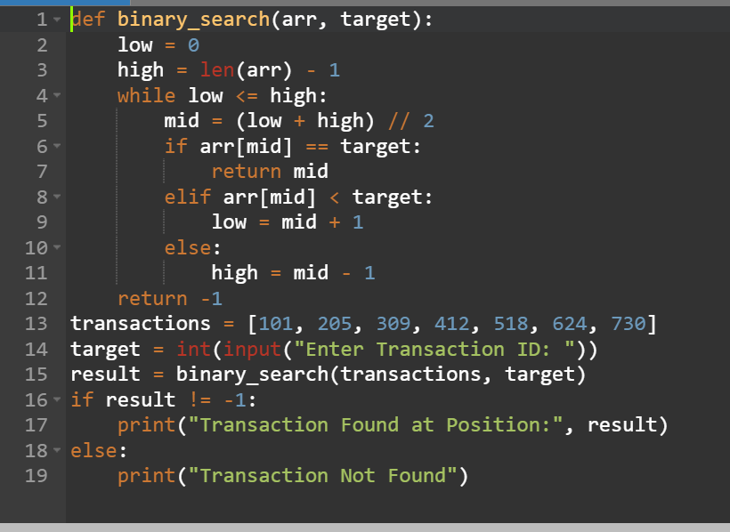
OUTPUT
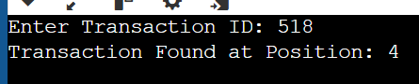

(b) Analyze its performance when order is maintained versus disturbed
When Order is Maintained
If the transaction data is sorted, Binary Search works efficiently by reducing the search space by half after every comparison.
Advantages
- Fast searching.
- Fewer comparisons.
- Suitable for large financial databases.
- Time Complexity: O(log n).
When Order is Disturbed
If frequent updates disturb the sorted order, Binary Search cannot work correctly because it requires sorted data.
Example:
[412, 101, 730, 205, 624, 309, 518]
In this case:
- Binary Search may produce incorrect results.
- The data must be sorted again before searching.
- Otherwise, Linear Search is required.
Comparison Table
Data Condition | Searching Method | Time Complexity
Sorted Data | Binary Search | O(log n)
Unsorted Data | Linear Search | O(n)
Sorting + Binary Search | Sorting + Binary Search | O(n log n)

Program Output Screenshot
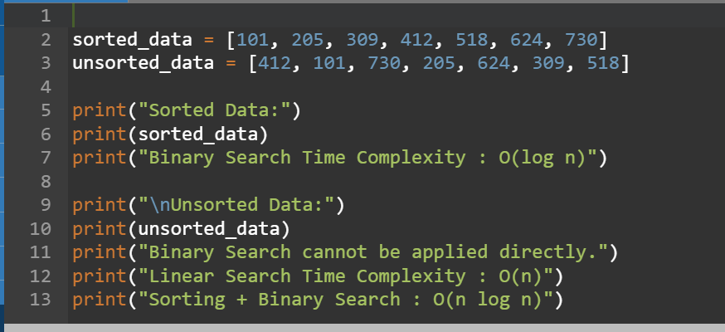
OUTPUT
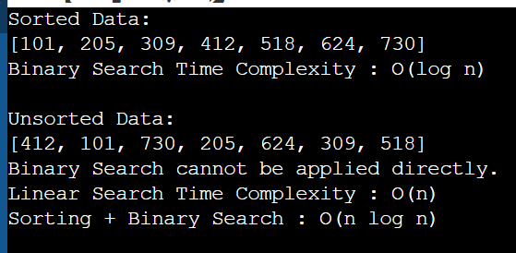

(c) Discuss the importance of maintaining sorted data
Maintaining sorted data is important because:
- It enables Binary Search to work correctly.
- It provides faster transaction retrieval.
- It reduces the number of comparisons.
- It improves system performance for large databases.
- It supports efficient financial transaction processing.
Analysis/Documentation Screenshot
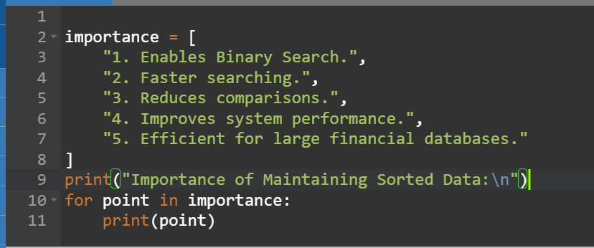
OUTPUT
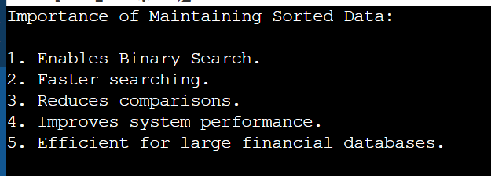

Conclusion
Binary Search is an efficient searching algorithm that works only on sorted data. Maintaining sorted transaction data improves search performance, reduces processing time, and ensures quick retrieval of financial records. If the data becomes unsorted due to frequent updates, Binary Search cannot be applied effectively until the data is sorted again.

